**RA Development**

# The project structure

RA component is located in **frms-platform** GIT repository. To checkout from Arbonaut GIT server:

http://vserver3:9009/scm/git/frms-platform

build datamodel frms-context

frms-report-app features

org.formis.nfis.desktop.feature org.formis.nfis.desktop.product

plugins

org.formis.nfis.desktop frms-syncclient

frms-test

Components are managed as Maven modules.

FRMS Reporting Application is an Eclipse e4 application built in the top of Eclipse Platform.

Current Eclispe SDK: **Eclipse Neon 3**

**org.formis.nfis.desktop** is a single plugin with business tailored logic.

**org.formis.nfis.desktop.feature** as a feature describing all OSGI bundles - dependencies.

**org.formis.nfis.desktop.product** is a location where RMS Report product configuration is and also place where Maven Tycho builds FRMS RA product as a ready application.

# Configuration

There is a single configuration file where credentials to connect to local (and optionally to online) databases located in

**org.formis.nfis.desktop** plugin:

/org.formis.nfis.desktop/config/frms.properties

If configuration in built RA component should be changed then this file can be found at:

Reports\plugins\org.formis.nfis.desktop_2.0.0.201709121200\config\frms.properties



Version of a plugin may have a different value: _2.0.0.201709121200

# Prepare Eclipse IDE development Environment

Configure Eclipse SDK in Eclipse IDE

Window -> Preferences -> Plug-In Development -> Target Platform -> Add..

Specify path to SDK resources extracted from ZIP file.



FTP> Eclispe SDK\Eclipse-Neon3-SDK-win32.zip

Eclipse Neon 3 SDK is located at FTP server:

## Configure and build projects

Load the following projects into Eclipse from frms-platform repository:

**/frms-platform** (parent Maven project)

**/frms-platform/frms-report-app/plugins/org.formis.nfis.desktop** (main FRMS RA plugin)

**/frms-platform/frms-report-app/features/org.formis.nfis.desktop.feature** (feature FRMS RA product is composed from) Execute Maven goals to prepare development of RA in Eclipse IDE:

### 

frms-platform> mvn --projects frms-context,frms-test --also-make clean install

frms-platform> mvn -f frms-report-app\plugins\org.formis.nfis.desktop\pom-libs.xml clean validate

At this stage Maven using commands above builds and installs locally artifact **frms-context** and also loads from Internet (from public Maven repositories) dependencies into directory

/frms-platform/frms-report-app/plugins/org.formis.nfis.desktop/libs

Now plugin **org.formis.nfis.desktop** can be built in Eclipse IDE.

## Launch configuration

Create launch configuration as follows:

#### Main

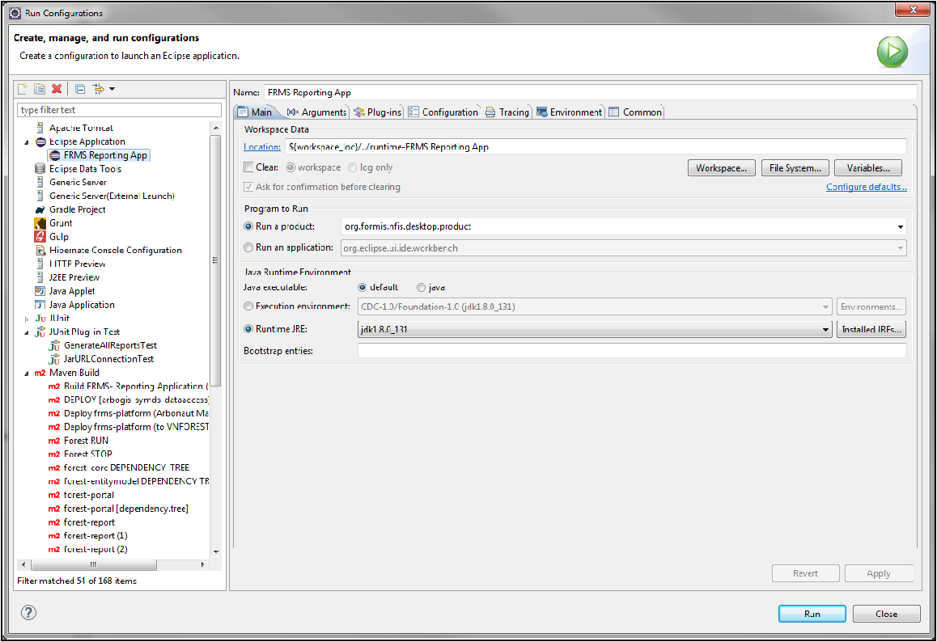

**Arguments**

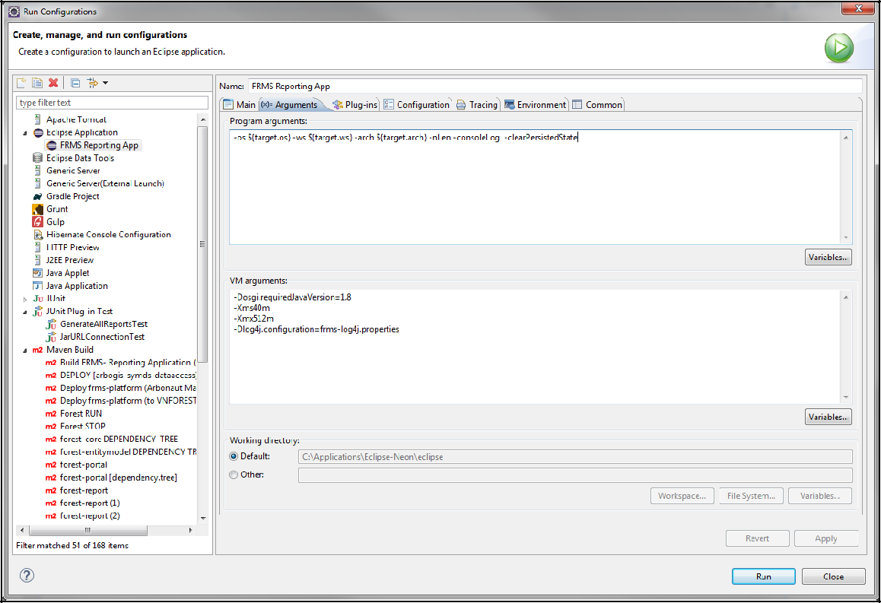

**Plug-Ins**

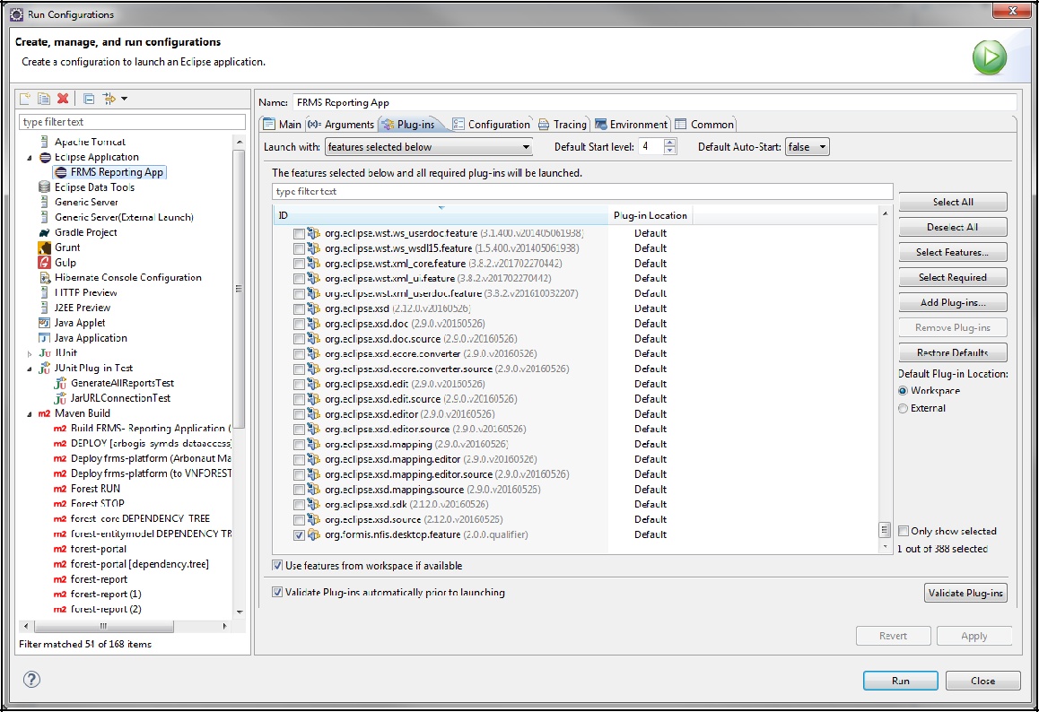

Run product. Of course, local database must be running :)

# Build by Maven Tycho

In order to build the RA component (FRMS Reporting Application) run several Maven commands within a working copy of **frms-platform**

repository.

 Build frms-context and other modules which are dependencies for RA:

### 

frms-platform> mvn --projects frms-context,frms-test --also-make clean install

 Download and place JAR depenencies to org.formis.nfis.desktop\libs directory:

frms-platform> mvn -f frms-report-app\plugins\org.formis.nfis.desktop\pom-libs.xml clean validate

 Build RA product by Maven Tycho plugin:

frms-platform> mvn -f frms-report-app\pom.xml clean install

As a result you get ready FRMS RA component at location:

/frms-platform/frms-report-app/features/org.formis.nfis.desktop.product/target/products/org.formis.nf

# CI at Jenkins

Also FRMS RA component is configured at Jenkins CI server to be fully built and deployed to **\\dell-testi\Powerline2\FRMS Vietnam\FRMS-2.0\ClientPackage-Components\RA**:

http://vserver3:8090/jenkins/job/FRMS-RA/

Nighly building process is configured.